CREATE TABLE product (
ProductID INT PRIMARY KEY,
ProductName VARCHAR(50),
SupplierID INT,
CategoryID INT,
Unit VARCHAR(50),
Price DECIMAL(4,4)
);

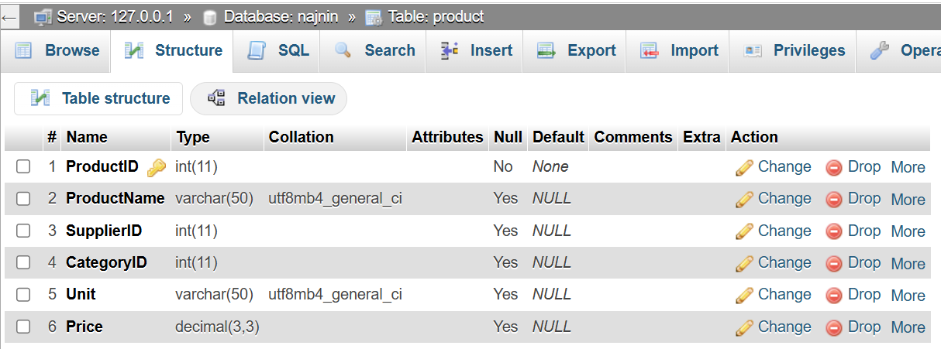

INSERT INTO product (ProductID, ProductName, SupplierID, CategoryID, Unit, Price)
VALUES
(1, 'Chais', 1, 1, '10 boxes', 18.00),
(2, 'Chang', 1, 1, '24 bottles', 19),
(3, 'Aniseed Syrup', 1, 2, '550 ml', 10.05),
(4, 'Chef Antons Cajun Seasoning', 2, 2, '48 jars', 22.50),
(5, 'Chef Antons Gumbo Mix', 2, 2, '36 boxes', 21.35);

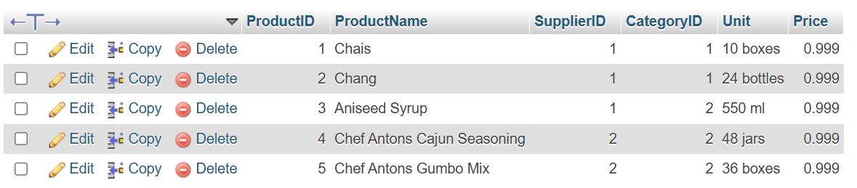

Madam, price insert hochche na.

In addition, ‘Anton’s’ insert hochche na.

SELECT * FROM `product` ORDER BY Price;

